Sensitivity to artificial missingness
DB1 daily patients (n=175): masking → VQ-VAE a0 → LDA, and the starting-missingness summary below. Alarm: all 1013 decision points (114 patients, 155 positive / 858 negative). Topics at landmarks, pUF, three-block load, F/U and alarm metrics use only those. Every decision has a load. Six end after the encoded profile and take the last 30 profile days, the same overlap as the collapsed month.

Initial missingness and the three masks
The extra mask is applied there, before the daily file enters VQ-VAE model. Dates, the first day and the last day do not move, so the calendar is not compressed and the origin does not shift when the first day is hidden. VQ-VAE a0, the LDA, the F/U grouping (topics 3–5) and the alarm threshold 1.0596 stay fixed. Five seeds: 101, 102, 103, 104, 105.
On all DB1 patients (n=175) the starting missingness is:
Fully missing days: mean 1.4% of the calendar. 152 of 175 patients have none. 23 have at least one.
Missing variables within a day that still has some measurement: mean 35.7%, median 34.7%. Tertiles at 23.5% and 43.2%. Counted over the whole calendar, with a fully empty day as nine empty variables, the mean is 36.1%. The table uses this second count, so the number of days is the same in every row.
From there, an extra 10%, 20%, 30%, 40% and 50% of what is still observed is hidden. The three masks are:
• Scattered days: whole days removed at random.
• Variables: cells removed among the nine VQ-VAE measures, inside days that still have data.
• Consecutive days: one contiguous block of that share of the calendar, at least 7 days. This is not the same share scattered across the calendar.
Added | Empty days | Empty variables
baseline | 1.4% | 36.1%
+10% days | 11.2% | 42.5%
+20% days | 21.1% | 48.9%
+30% days | 30.9% | 55.3%
+40% days | 40.8% | 61.6%
+50% days | 50.7% | 68.1%
+10% variables | 2.2% | 42.5%
+20% variables | 3.2% | 48.9%
+30% variables | 4.4% | 55.3%
+40% variables | 6.0% | 61.7%
+50% variables | 8.6% | 68.1%
+10% consecutive days | 13.5% | 43.5%
+20% consecutive days | 22.5% | 49.4%
+30% consecutive days | 31.9% | 55.6%
+40% consecutive days | 41.4% | 61.9%
+50% consecutive days | 51.2% | 68.3%

Topics
In the tables and figures that follow, each value is the mean of the five seeds. The bracket, and the band on the figure, is the 95% confidence interval of that mean. The baseline is a single run, so it has no interval.
Day-types and topics are compared with the initial run. JS is the Jensen–Shannon divergence of the global distribution. Topic MAE is the mean absolute difference of the six topic probabilities. Topic cosine is the correlation of the global distribution of the monthly dominant topic with the initial run. Dominant is the fraction of months whose dominant topic stays the same.
Both distributions stay close through +30% of scattered days or variables. A contiguous block moves them more: the topic cosine is 0.842 at +20% consecutive and 0.423 at +50%, against 0.984 and 0.798 for the same shares of scattered days.
Added | Day-type JS | Topic JS | Topic MAE | Topic cosine | Dominant
baseline | 0 | 0 | 0 | 1 | 1
+10% days | 0.007 | 0.001 | 0.013 [0.012, 0.013] | 0.997 [0.996, 0.997] | 0.927 [0.917, 0.936]
+20% days | 0.023 | 0.006 [0.005, 0.006] | 0.028 | 0.984 [0.981, 0.986] | 0.859 [0.849, 0.869]
+30% days | 0.046 [0.046, 0.047] | 0.015 [0.015, 0.016] | 0.049 [0.048, 0.050] | 0.955 [0.952, 0.958] | 0.783 [0.772, 0.794]
+40% days | 0.078 [0.077, 0.078] | 0.031 | 0.073 [0.073, 0.074] | 0.899 [0.888, 0.911] | 0.682 [0.669, 0.695]
+50% days | 0.115 [0.114, 0.116] | 0.056 [0.054, 0.057] | 0.100 [0.098, 0.101] | 0.798 [0.784, 0.812] | 0.558 [0.535, 0.580]
+10% variables | 0.004 | 0.001 | 0.013 [0.011, 0.014] | 0.996 [0.994, 0.998] | 0.912 [0.903, 0.921]
+20% variables | 0.015 [0.014, 0.015] | 0.005 [0.004, 0.005] | 0.026 [0.025, 0.027] | 0.983 [0.978, 0.987] | 0.852 [0.839, 0.866]
+30% variables | 0.033 [0.033, 0.034] | 0.013 [0.012, 0.013] | 0.042 [0.041, 0.043] | 0.948 [0.944, 0.952] | 0.766 [0.760, 0.772]
+40% variables | 0.061 [0.061, 0.062] | 0.026 [0.026, 0.027] | 0.061 [0.060, 0.062] | 0.886 [0.880, 0.891] | 0.671 [0.662, 0.680]
+50% variables | 0.099 [0.098, 0.100] | 0.050 [0.049, 0.051] | 0.088 [0.087, 0.089] | 0.758 [0.742, 0.775] | 0.546 [0.527, 0.564]
+10% consecutive days | 0.011 | 0.009 [0.008, 0.011] | 0.031 [0.029, 0.034] | 0.958 [0.950, 0.966] | 0.886 [0.875, 0.896]
+20% consecutive days | 0.035 [0.034, 0.036] | 0.034 [0.032, 0.037] | 0.068 [0.064, 0.071] | 0.842 [0.828, 0.856] | 0.772 [0.762, 0.783]
+30% consecutive days | 0.067 [0.065, 0.068] | 0.072 [0.068, 0.076] | 0.107 [0.103, 0.110] | 0.684 [0.669, 0.699] | 0.652 [0.638, 0.666]
+40% consecutive days | 0.104 [0.102, 0.105] | 0.120 [0.115, 0.125] | 0.146 [0.142, 0.149] | 0.537 [0.525, 0.549] | 0.530 [0.517, 0.543]
+50% consecutive days | 0.148 [0.146, 0.149] | 0.179 [0.172, 0.185] | 0.184 [0.180, 0.188] | 0.423 [0.413, 0.432] | 0.415 [0.401, 0.428]

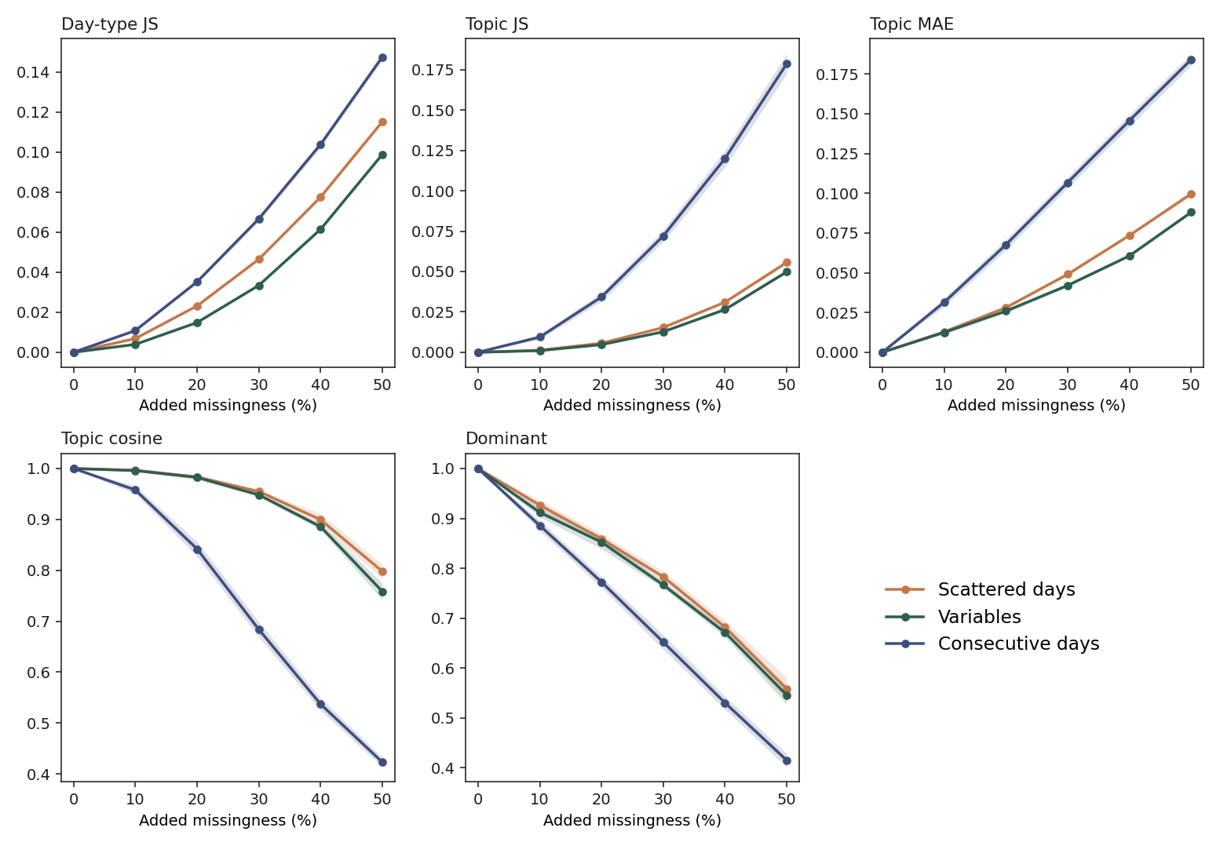

Monthly pUF and three-block load
The monthly pUF is the unfavourable-topic mass of a 30-day block. The load is the sum of three consecutive blocks, and it is the score of the alarm. Correlation and absolute difference are against the initial run, on the same 1013 objetivo landmarks.
Scattered days and variables keep the load correlation above 0.90 through +40%, and at +50% it is 0.859 and 0.844. Consecutive days pull it down earlier: 0.797 at +20% and 0.463 at +50%. The absolute difference of the load at +50% is 0.365 for scattered days, 0.426 for variables and 0.822 for a consecutive block.
Added | pUF corr. | pUF MAE | Load corr. | Load MAE
baseline | 1 | 0 | 1 | 0
+10% days | 0.979 [0.978, 0.979] | 0.043 [0.042, 0.045] | 0.990 [0.989, 0.990] | 0.093 [0.092, 0.095]
+20% days | 0.950 [0.948, 0.953] | 0.072 [0.070, 0.074] | 0.973 [0.970, 0.975] | 0.159 [0.153, 0.165]
+30% days | 0.911 [0.909, 0.914] | 0.100 [0.098, 0.101] | 0.945 [0.943, 0.948] | 0.229 [0.225, 0.233]
+40% days | 0.859 [0.851, 0.868] | 0.127 [0.124, 0.130] | 0.909 [0.901, 0.918] | 0.292 [0.279, 0.306]
+50% days | 0.793 [0.786, 0.801] | 0.154 [0.151, 0.158] | 0.859 [0.849, 0.868] | 0.365 [0.354, 0.377]
+10% variables | 0.973 [0.972, 0.975] | 0.052 [0.050, 0.053] | 0.987 [0.986, 0.988] | 0.107 [0.103, 0.111]
+20% variables | 0.947 [0.944, 0.950] | 0.075 [0.073, 0.077] | 0.971 [0.968, 0.974] | 0.163 [0.156, 0.170]
+30% variables | 0.911 [0.909, 0.913] | 0.101 [0.099, 0.104] | 0.947 [0.944, 0.950] | 0.231 [0.224, 0.238]
+40% variables | 0.864 [0.856, 0.871] | 0.130 [0.127, 0.132] | 0.906 [0.899, 0.914] | 0.316 [0.307, 0.325]
+50% variables | 0.791 [0.784, 0.799] | 0.167 [0.164, 0.170] | 0.844 [0.836, 0.851] | 0.426 [0.416, 0.435]
+10% consecutive days | 0.886 [0.876, 0.896] | 0.051 [0.046, 0.056] | 0.928 [0.922, 0.933] | 0.152 [0.138, 0.166]
+20% consecutive days | 0.757 [0.739, 0.775] | 0.105 [0.097, 0.114] | 0.797 [0.785, 0.809] | 0.315 [0.290, 0.339]
+30% consecutive days | 0.640 [0.620, 0.661] | 0.163 [0.153, 0.173] | 0.670 [0.654, 0.685] | 0.486 [0.456, 0.517]
+40% consecutive days | 0.537 [0.518, 0.556] | 0.219 [0.209, 0.230] | 0.559 [0.545, 0.573] | 0.657 [0.626, 0.687]
+50% consecutive days | 0.443 [0.422, 0.463] | 0.274 [0.264, 0.285] | 0.463 [0.447, 0.479] | 0.822 [0.791, 0.853]

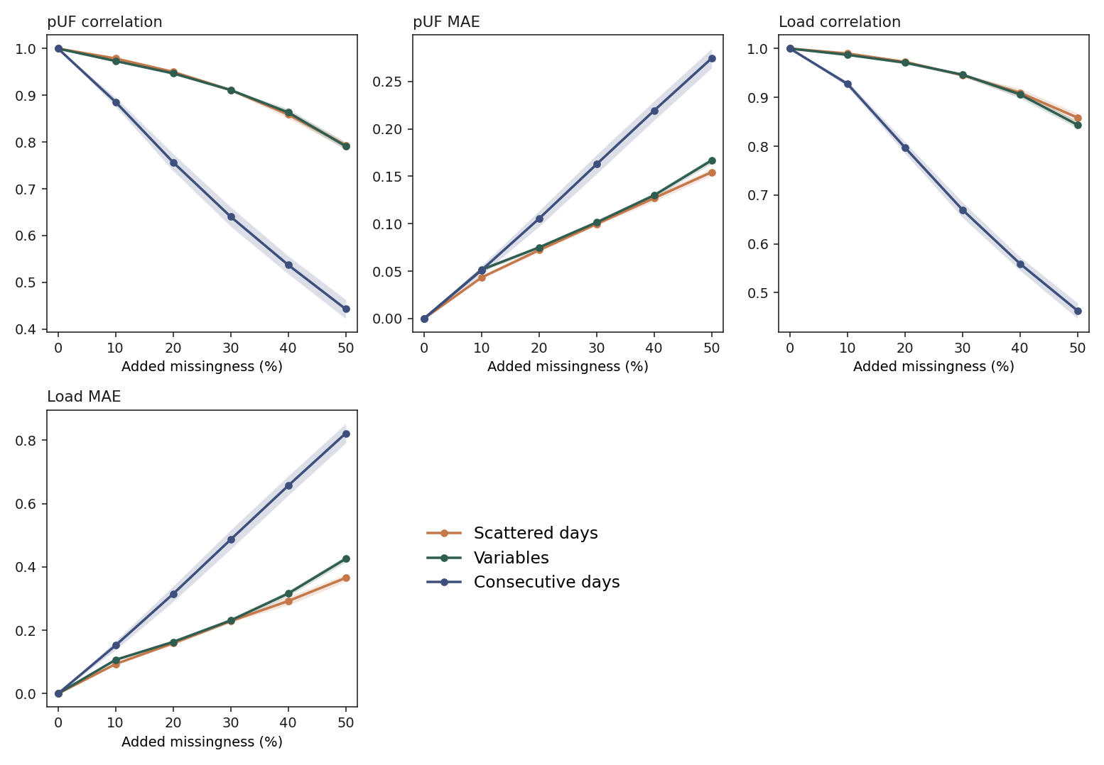
Figure: rampa_carga.svg.

Alarm
The threshold stays at 1.0596 and is not re-chosen. All 1013 decisions have a load, and that baseline load matches the stored collapsed load (MAE 0.0019). At baseline, AUROC 0.703, sensitivity 0.884, specificity 0.452, PPV 0.226, NPV 0.956. Of the 1013 points, 1006 meet the 15-day rule, and 113 of the 114 patients have at least one such point. The alarm metrics use every load.
Mean over the five seeds, on the same 1013 landmarks (155 positive / 858 negative). The grey line is a random alarm. For AUROC, sensitivity and specificity that chance level is 0.5. For PPV it is 0.153 and for NPV 0.847, the share of positive and negative points. In the tables, each cell is the mean across seeds; the bracket is the 95% confidence interval over the five seeds.
Added | AUROC | Sensitivity | Specificity | PPV | NPV
baseline | 0.703 | 0.884 | 0.452 | 0.226 | 0.956
+10% days | 0.702 [0.698, 0.706] | 0.859 [0.838, 0.881] | 0.447 [0.442, 0.451] | 0.219 [0.214, 0.224] | 0.946 [0.938, 0.954]
+20% days | 0.709 [0.702, 0.716] | 0.859 [0.835, 0.884] | 0.430 [0.424, 0.436] | 0.214 [0.210, 0.218] | 0.944 [0.936, 0.953]
+30% days | 0.701 [0.691, 0.711] | 0.875 [0.868, 0.882] | 0.392 [0.383, 0.401] | 0.206 [0.204, 0.209] | 0.946 [0.943, 0.948]
+40% days | 0.686 [0.679, 0.693] | 0.871 [0.846, 0.896] | 0.385 [0.381, 0.389] | 0.204 [0.198, 0.209] | 0.943 [0.932, 0.954]
+50% days | 0.680 [0.660, 0.700] | 0.825 [0.786, 0.863] | 0.412 [0.396, 0.428] | 0.202 [0.192, 0.213] | 0.929 [0.912, 0.945]
+10% variables | 0.705 [0.698, 0.712] | 0.857 [0.846, 0.867] | 0.450 [0.445, 0.454] | 0.220 [0.218, 0.221] | 0.946 [0.942, 0.949]
+20% variables | 0.709 [0.704, 0.715] | 0.875 [0.866, 0.884] | 0.434 [0.426, 0.443] | 0.218 [0.215, 0.222] | 0.951 [0.947, 0.954]
+30% variables | 0.705 [0.700, 0.711] | 0.885 [0.870, 0.901] | 0.395 [0.388, 0.401] | 0.209 [0.206, 0.212] | 0.950 [0.944, 0.956]
+40% variables | 0.697 [0.689, 0.705] | 0.899 [0.869, 0.930] | 0.350 [0.343, 0.357] | 0.200 [0.194, 0.206] | 0.951 [0.936, 0.965]
+50% variables | 0.674 [0.662, 0.686] | 0.902 [0.883, 0.921] | 0.282 [0.266, 0.297] | 0.185 [0.179, 0.190] | 0.941 [0.928, 0.953]
+10% consecutive days | 0.692 [0.675, 0.709] | 0.818 [0.795, 0.841] | 0.516 [0.503, 0.529] | 0.234 [0.225, 0.243] | 0.940 [0.932, 0.948]
+20% consecutive days | 0.670 [0.644, 0.696] | 0.684 [0.654, 0.714] | 0.587 [0.570, 0.605] | 0.230 [0.223, 0.238] | 0.911 [0.905, 0.918]
+30% consecutive days | 0.648 [0.615, 0.682] | 0.560 [0.509, 0.611] | 0.656 [0.635, 0.677] | 0.227 [0.206, 0.249] | 0.892 [0.879, 0.904]
+40% consecutive days | 0.642 [0.607, 0.677] | 0.437 [0.371, 0.504] | 0.731 [0.709, 0.753] | 0.227 [0.199, 0.255] | 0.878 [0.866, 0.891]
+50% consecutive days | 0.641 [0.611, 0.672] | 0.326 [0.259, 0.394] | 0.801 [0.786, 0.816] | 0.228 [0.193, 0.263] | 0.868 [0.858, 0.879]

For scattered days and for variables, AUROC stays near 0.70 through +30%, and at +50% it is 0.680 and 0.674. When variables are missing, sensitivity at +50% is still 0.902 while specificity falls to 0.282: the load drifts upward and more alarms turn on. When scattered days are missing, sensitivity falls to 0.825 and specificity stays near 0.41.
Consecutive days lower the load, so alarms turn off. AUROC at +10% is 0.692 and at +50% is 0.641. Sensitivity falls to 0.326 and specificity rises to 0.801. At +20% consecutive, AUROC is 0.670 versus 0.709 when those days are removed scattered, and 147 alarms turn off with none turning on.
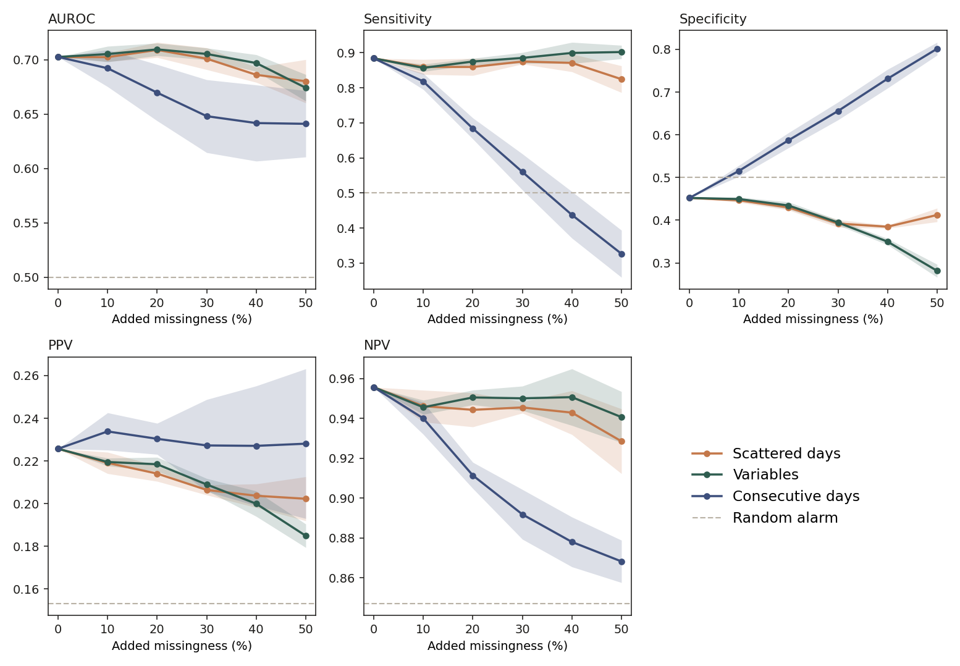
F/U is the favourable or unfavourable group of the monthly dominant topic. Alarm is the on or off decision at the fixed threshold. Turns on and turns off count decisions that cross that threshold. Points are landmarks that were valid and then fail the 15-day rule. Patients are those who had at least one valid landmark and then have none.
Added | F/U | Alarm | Turns on | Turns off | Points lost | Patients lost
baseline | 1 | 1 | 0 | 0 | 0 | 0
+10% days | 0.957 [0.947, 0.966] | 0.964 [0.957, 0.971] | 19 [15, 22] | 18 [13, 22] | 1 | 1
+20% days | 0.923 [0.918, 0.928] | 0.934 [0.926, 0.941] | 41 [33, 49] | 26 [25, 27] | 2 [0, 3] | 1
+30% days | 0.884 [0.875, 0.893] | 0.898 [0.893, 0.903] | 77 [72, 82] | 27 [22, 31] | 14 [4, 25] | 1
+40% days | 0.841 [0.830, 0.853] | 0.872 [0.863, 0.881] | 93 [88, 98] | 37 [33, 41] | 256 [247, 265] | 5 [2, 7]
+50% days | 0.784 [0.770, 0.798] | 0.853 [0.843, 0.864] | 87 [79, 95] | 62 [54, 69] | 833 [820, 847] | 43 [35, 52]
+10% variables | 0.948 [0.942, 0.954] | 0.955 [0.945, 0.964] | 22 [19, 25] | 24 [17, 31] | 1 [0, 1] | 1 [0, 1]
+20% variables | 0.918 [0.911, 0.925] | 0.929 [0.922, 0.936] | 43 [37, 49] | 29 [26, 32] | 1 [0, 1] | 1 [0, 1]
+30% variables | 0.877 [0.871, 0.884] | 0.896 [0.883, 0.909] | 77 [71, 84] | 28 [20, 36] | 2 [0, 4] | 1
+40% variables | 0.825 [0.819, 0.831] | 0.850 [0.841, 0.859] | 121 [113, 129] | 31 [27, 34] | 13 [10, 16] | 1
+50% variables | 0.771 [0.756, 0.786] | 0.790 [0.783, 0.797] | 181 [172, 190] | 32 [29, 34] | 39 [29, 48] | 1
+10% consecutive days | 0.936 [0.931, 0.941] | 0.936 [0.927, 0.946] | 0 | 65 [55, 74] | 230 [214, 246] | 4 [3, 4]
+20% consecutive days | 0.880 [0.874, 0.886] | 0.855 [0.837, 0.873] | 0 | 147 [129, 165] | 370 [347, 393] | 10 [8, 13]
+30% consecutive days | 0.821 [0.810, 0.832] | 0.778 [0.761, 0.795] | 0 | 225 [207, 242] | 494 [469, 519] | 16 [13, 20]
+40% consecutive days | 0.761 [0.745, 0.776] | 0.695 [0.672, 0.718] | 0 [0, 1] | 309 [286, 332] | 614 [594, 634] | 23 [19, 27]
+50% consecutive days | 0.705 [0.689, 0.720] | 0.619 [0.600, 0.638] | 0 | 386 [367, 405] | 730 [711, 748] | 33 [28, 37]

At +40% scattered days, 256 of the 1006 points that meet the 15-day rule are lost and 5 of the 113 patients lose every such point. At +50%, 833 points and 43 patients are lost. With variables, at +50%, 39 points are lost and 1 patient loses every such point. A consecutive block at +50% loses 730 points and 33 patients, and turns 386 alarms off. At +50% scattered days, 87 alarms turn on and 62 turn off; with variables, 181 turn on and 32 turn off.

One patient example
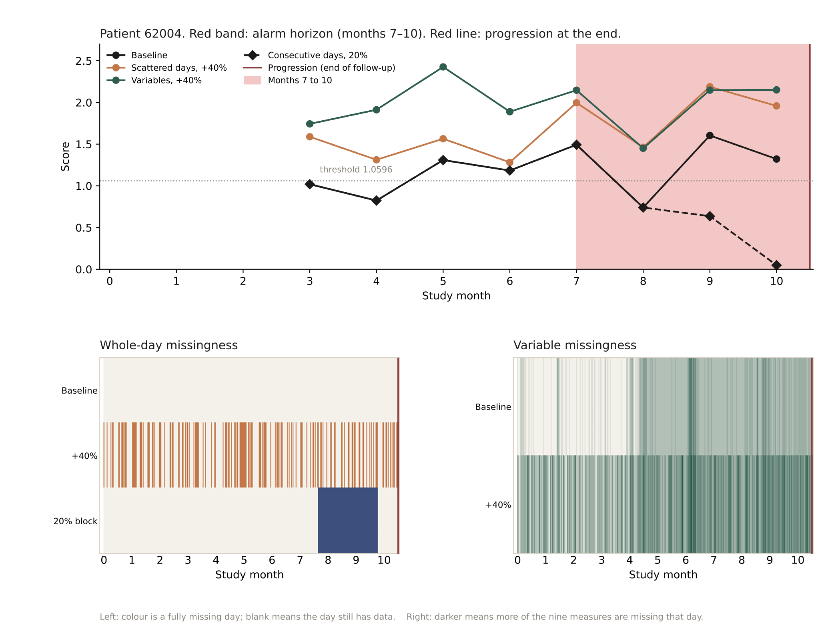
Figure: ejemplo_62004.svg.
Contiguous gaps of 3, 7 and 14 days
One extra block, separate from the 10–50% ramp. On each of the 175 DB1 patients a single run of 3, 7 or 14 calendar days is hidden, placed at random with seeds 101–105. The same VQ-VAE, LDA and threshold are kept. Two patients have a calendar shorter than 14 days, so that gap covers their whole span. Every one of the 1013 decisions still has a load.
The posterior is the mean topic distribution of those 1013 months. Its Jensen–Shannon divergence from the unmasked run is below 0.001 at 3 and 7 days and 0.001 at 14 days. The mean absolute difference of the six probabilities is 0.001, 0.004 and 0.010. Dominant-state agreement is the fraction of months whose winning topic stays the same. Threshold-crossing agreement is the fraction whose alarm stays on the same side of 1.0596. Availability is the 15-day rule: at baseline 1006 points meet it.
Gap | Posterior JS | Posterior MAE | Dominant | Threshold | Turns off | Points lost | AUROC | Sensitivity | Specificity
3 days | <0.001 | 0.001 [0.001, 0.002] | 0.995 [0.991, 0.998] | 0.995 [0.991, 0.999] | 3 [0, 6] | 0 [0, 1] | 0.703 [0.702, 0.704] | 0.876 [0.862, 0.890] | 0.452 [0.451, 0.454]
7 days | <0.001 | 0.004 [0.003, 0.005] | 0.992 [0.987, 0.996] | 0.992 [0.987, 0.996] | 8 [5, 11] | 1 [0, 1] | 0.696 [0.692, 0.699] | 0.862 [0.847, 0.876] | 0.456 [0.455, 0.458]
14 days | 0.001 | 0.010 [0.009, 0.011] | 0.960 [0.955, 0.965] | 0.983 [0.979, 0.987] | 17 [13, 21] | 3 [1, 4] | 0.688 [0.680, 0.696] | 0.852 [0.835, 0.869] | 0.466 [0.462, 0.470]
Per-seed file: results/missingness/huecos_3_7_14/metricas_por_semilla.csv.

